Winter-proofing 101: Ways to prepare your home for the cold

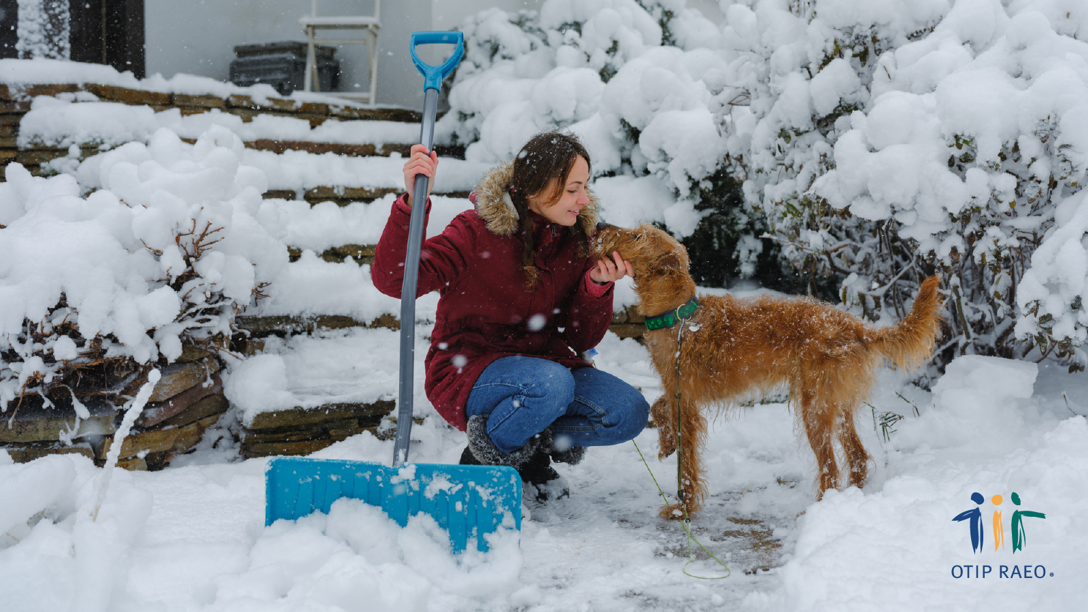

As winter approaches, Canadians understand that while the beauty of snow-covered landscapes is enchanting, it also brings the challenge of keeping our homes safe and warm. Cold weather can present significant risks to both property and personal safety. From freezing temperatures to heavy snowfall, it's important to prepare your home for the upcoming season. Here's a handy checklist of cold weather safety tips to ensure you're ready for the winter months.

Read more at www.otip.com/article197. #OTIPUpdate

Celebrate the holiday season with a bonus offer!

For the month of December, receive a $30 gift card when you get a car, home, or leisure insurance quote. Get a quote or call 1-888-892-4935 and mention this offer.

