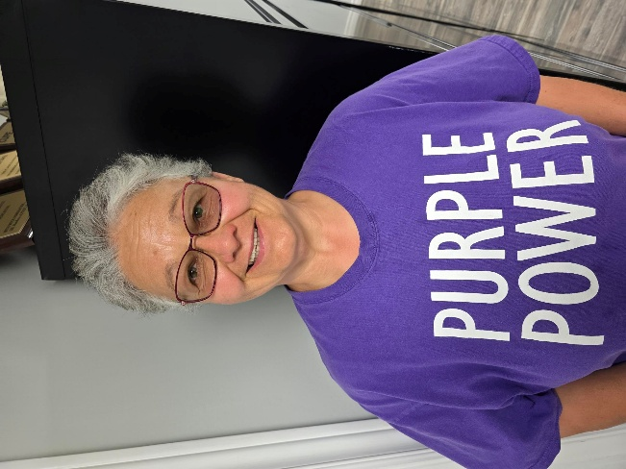
VOTE
MARILYN MAC ALONEY
for
MEMBER-AT-LARGE
CUPE 4153 NEGOTIATING COMMITTEE
Thursday ~ June 19th

Hello Brothers and Sisters of CUPE 4153.
My name is Marilyn MacAloney, and I have been nominated for Member-at-Large on the CUPE 4153 Negotiating Committee.
My history with union activities includes working in a plastics factory for over 20 years. Within those years I became involved in the union as a Health and Safety Representative. This was the time that accidents were happening every time you turned your head. We had a lot of work ahead of us but with constant pressure from our members and activists we conquered many problems. I also started up a Social Committee which brought the members closer together at a time when it was much needed.
Next, I spent ten years at a corrugated factory. Again, I got involved with the Union as a Safety Core Rep. and was involved with the Social Committee. There were many safety infractions at this site. I am not saying our committee changed the world, but we did slow down the accidents with the proper education training needs that were required.
Which brings me here to HWDSB as a Head Caretaker. As some of you are aware, I am still a Health and Safety Rep and also serve as your Secretary-Treasurer on the Executive Committee.
We have a work force that has many years of history and so few of us are lucky enough to learn from them. We need to stand up and fight for ourselves and prove we are worth the fight. I have heard over and over that in our last round of bargaining “we didn’t get this” or “why didn’t you fight for that”. I will always listen to our membership and only make decisions that will benefit us all. I promise to fight the best fight I can with what is available to me - NO CONCESSIONS ~ BETTER PAY!

PLEASE CHECK YOUR PERSONAL EMAILS ON JUNE 16TH FOR YOUR BALLOT
AND VOTE FOR MARILYN!

