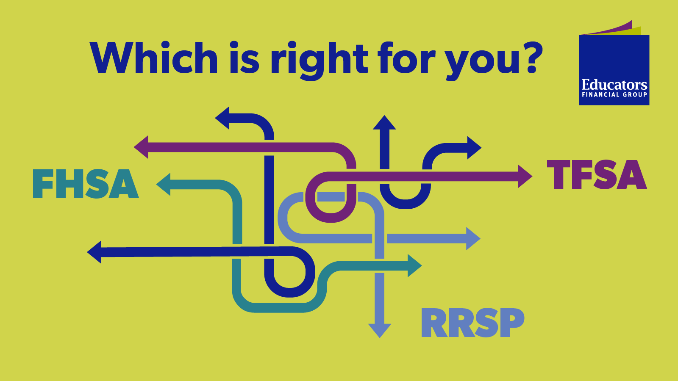

Not sure which account is right for your investment goals? Compare the benefits of a TFSA, RRSP, and FHSA to find the best option for you. Plus, for a limited time, open a TFSA, RRSP, or FHSA and you could win $1,000*: <https://bit.ly/4g4Ph2v>. Brought to you by *(please tag* **@Educators Financial Group** *on* ***Facebook*** *or* **@EducatorsFG** *on* ***Twitter/Instagram****)*.