JUNE
GMM
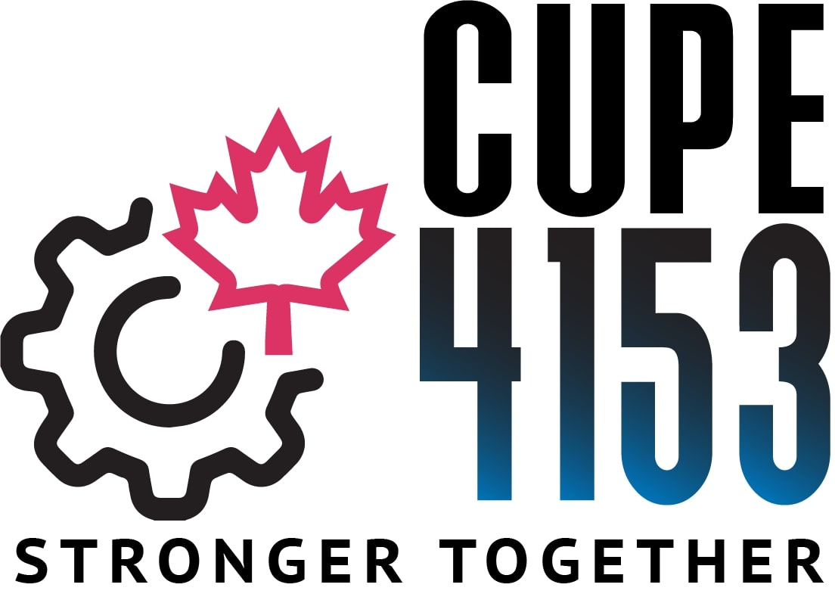

Sunday ~ June 26, 2022
10:00 am – 12:00 pm

LOCATION: HWETL HALL, 105 NEBO ROAD

AGENDA:
- Swearing In of Elected Officers
- Nominations for Bargaining Committee
3. Regular Union Business

