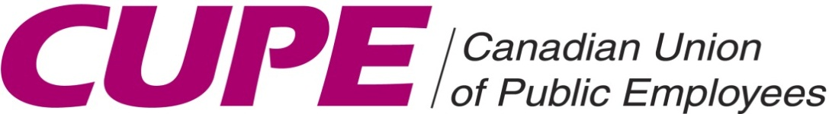 | Local 4153

AGENDA
GENERAL MEMBERSHIP MEETING
Sunday ~ May 15, 2022

- Call to Order

- Roll Call

- Equality Statement

- New Members

- Minutes of Last Meeting
-April, 2022

- Treasurer’s Report
-April, 2022

- Correspondence

9. Committee Reports
- Grievance Committee
- Health & Safety Committee
- PD Day Committee: Motion for Water Bottles
- Staff Relations Committee
- Social Committee: Motion for Funds and Separate Bank Account
- Training Committee
- Wellness / WSIB Committee
- Women’s Committee
- Workload (Schedules) Committee

10. Nominations & Elections
- Nominations for General Election
- General Election June 23, 2022

11. Unfinished Business
- Trustee Report on 2021 Financial Audit and President/Sec-Treasurer Response

12. New Business
- Hybrid General Membership Meetings
- CUPE 4153 Signage

13. Good of the Union

14. Adjournment

