APRIL
GMM
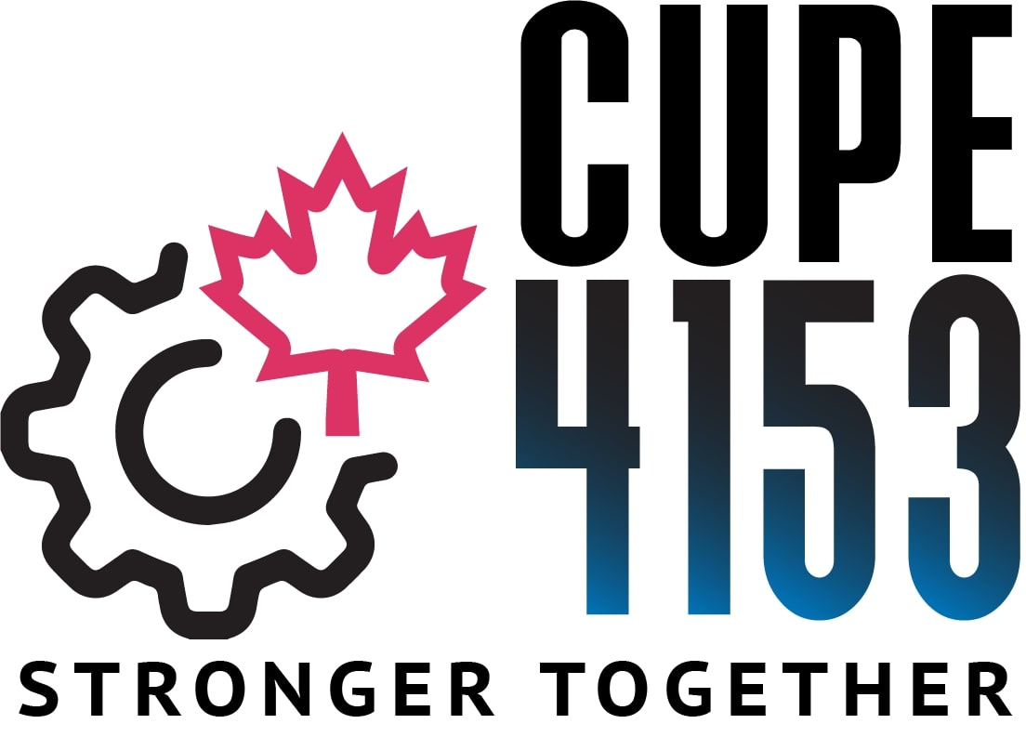

Sunday ~ April 24, 2022
10:00 am – 12:00 pm

LOCATION: HWETL HALL, 105 NEBO ROAD

AGENDA:
- Trustee Report on 2021 Financial Audit
- OSBCU Letter to the Next Premier
- June 23rd General Election
4. Regular Union Business

