GMM
ZOOM
CALL
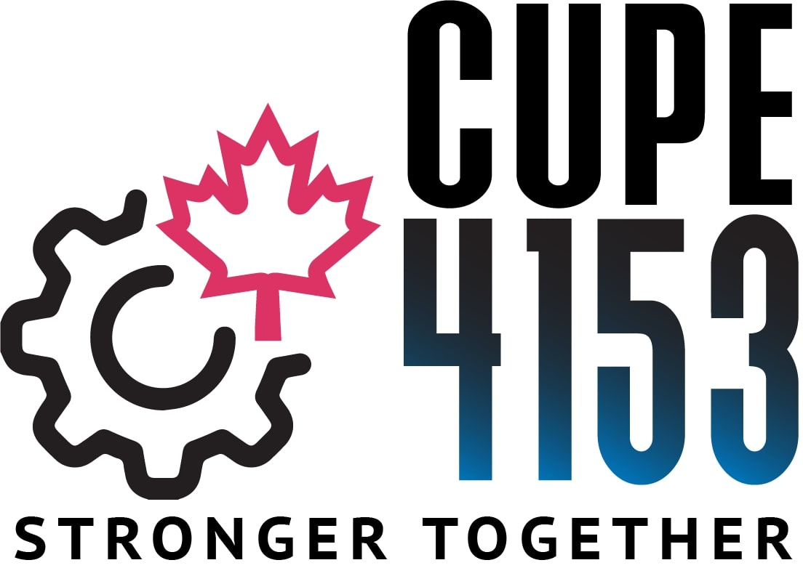

Sunday ~ March 20, 2022
10:00 am – 12:00 pm

AGENDA:
- The Union Office Has Moved!
- Bargaining Survey and Future Important Dates
- Classroom Conditions
2. Regular Union Business

TO JOIN ZOOM MEETING:
https://us02web.zoom.us/j/83101858167?pwd=MjBvYTVTelF2bEJsSjgvVmcweDRyQT09
Meeting ID: 831 0185 8167
Passcode: 344891
One tap mobile
+14388097799,,83101858167#,,,,*344891# Canada
+15873281099,,83101858167#,,,,*344891# Canada
Dial by your location
+1 438 809 7799 Canada
+1 587 328 1099 Canada
+1 613 209 3054 Canada
+1 647 374 4685 Canada
+1 647 558 0588 Canada
+1 778 907 2071 Canada
+1 204 272 7920 Canada
Meeting ID: 831 0185 8167
Passcode: 344891
Find your local number: https://us02web.zoom.us/u/ksd7XLImI

