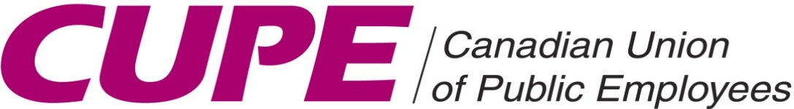 | Local 4153

GENERAL MEMBERSHIP MEETING

Sunday ~ November 21, 2021
10:00 am – 12:00 pm

AGENDA:
Regular Union Business

Join Zoom Meeting
https://us02web.zoom.us/j/82104336452?pwd=cXJscmpKRXREU2R6WmZHY1B5S0lRQT09
Meeting ID: 821 0433 6452
Passcode: 454213
One tap mobile
+15873281099,,82104336452#,,,,*454213# Canada
+16132093054,,82104336452#,,,,*454213# Canada
Dial by your location
+1 647 374 4685 Canada
+1 647 558 0588 Canada
Meeting ID: 821 0433 6452
Passcode: 454213
Find your local number: https://us02web.zoom.us/u/kbe8ujPQ1o

