GMM
ZOOM
CALL
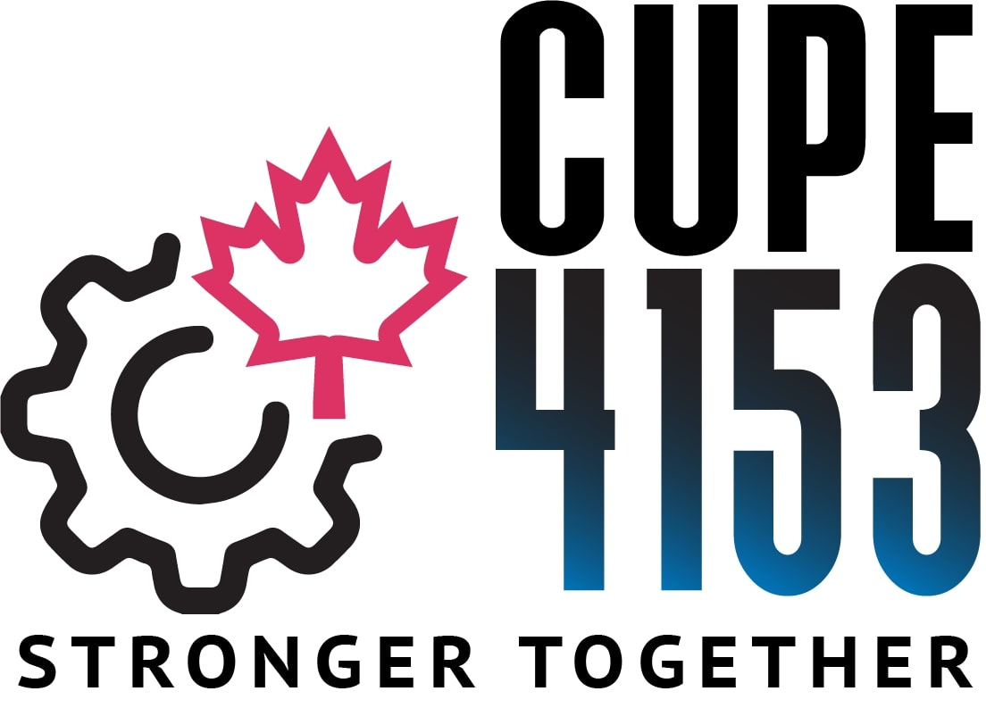

Sunday ~ September 19, 2021
10:00 am – 12:00 pm

AGENDA:
1. Notice to Amend Bylaws
(Special GMM on September 26, 2021 to review and approve Bylaw Revisions)
2. Regular Union Business

TO JOIN ZOOM MEETING:
https://us02web.zoom.us/j/87627760708?pwd=YlBnd3MxSXhRS3c4TUtRUEoxYVRKdz09
Meeting ID: 876 2776 0708
Passcode: 372464
One tap mobile
+15873281099,,87627760708#,,,,*372464# Canada
+16132093054,,87627760708#,,,,*372464# Canada
Dial by your location
+1 587 328 1099 Canada
+1 613 209 3054 Canada
+1 647 374 4685 Canada
+1 647 558 0588 Canada
+1 778 907 2071 Canada
+1 204 272 7920 Canada
+1 438 809 7799 Canada
Meeting ID: 876 2776 0708
Passcode: 372464
Passcode: 837745
Find your local number: https://us02web.zoom.us/u/ket3VdPPnY

